

Rules translation by
Mike Smith and Ken Tidwell
Reformatted and clarified by Bill Koens
El Grande

Overview
The game is based on Spain in the 13th – 15th Centuries. The aristocracy, especially the Grandes, the high aristocracy, controlled events in Spain. However, the lower aristocracy, the Caballeros, also enjoyed extensive powers. All regions wanted to develop their own power and influence. The kings were relatively weak and often manipulated by the aristocracy.
In El Grande, each player is a Grande family from one region. They have 30 Caballeros in their faction. Each Grande attempts, for the benefit of Spain, and for his own benefit, to extend his influence across the whole of Spain. To accomplish this he must control the majority of Caballeros in as many regions as possible. The Grande who succeeds in this is on the path to success and winning the game. Rounds 1–3 represent the 13th Century, 4–6 the 14th Century, and 7–9 the 15th Century.

What's in the Box
One game board
Five Grandes (large cubes) in five colors
155 Caballeros (small cubes) in five colors (31 per color)
One King (large black pawn)
One round marker (small black cube)
65 power cards in five colors (with values 1 to 13 in each color)
45 action cards
Nine region cards (with a rule summary on the reverse, in German)
Five secrecy disks with pointers
One Castillo (Castle)
Two scoreboards with the values “8/4/0” and “4/0/0”

The Board
The board shows the nine regions of Spain, one space to hold the Castillo, the scoring track along the edge of the board, and a chart with nine game rounds and three horizontal scoring tracks. There is a scoreboard with three symbols in each region which show the values of the various regions. The player with the most Caballeros in a region scores the highest value, whoever has the second most scores the second value, etc.

Duration
The game may be played in nine or six rounds. The game takes around two hours for nine rounds and around one hour for six rounds. If you want to play the shorter game, you should skip rounds 1, 4, and 7, so there are only two rounds of play before each scoring round.

Preparations
Castillo: Place the castle on the appropriate space on the game board.
Region Cards: Shuffle the nine region cards. Turn up the top card and place the King in this region. Then deal each player a card. They place their Grande (the large cube) in this region; this is their home region.
Caballeros: Each player places two Caballeros of their color in their home region. Another is placed on the first space of the scoring track. The seven more Caballeros are placed in from of the player; this area in front of each player is called the player’s court. The remaining Caballeros of each color are placed into a large pile near the board; this reserve is known as the provinces.
Secrecy Disk: Each player gets a secrecy disk. It shows each region on the board with the exception of the Castillo.
Power Cards: Each player gets a set of power cards in their color. The value of the power card is shown on the top and bottom of the card and the middle shows a number of Caballeros.
Action Cards: These are marked on the back with between one and five Caballeros. All eleven cards with one Caballero form the 1 pile, all eleven cards with two Caballeros form the 2 pile, and so on. The 5 pile is made up of just one card (the King card). Each pile is individually shuffled and placed face down beside the board.
Scoreboards: Both scoreboards are placed beside the board.

Playing the Game
The game consists of nine rounds of play. After rounds three, six, and nine, players score points in each region. Additionally, players can score regions in any round due to the play of certain action cards. A game round is made up of the following actions:
(1) Move the round counter forward
(2) Uncover the top action card in each pile
(3) Play power cards
(4) Each player takes their turn (the sequence is determined by the value of the power cards played)

Move the round counter (Black Cube)
At the start of the game the round counter is placed on the ‘1’ space of the round chart. Each round the counter is moved one space further down the chart. General scoring occurs at the end of the 3rd, 6th, and 9th rounds.

Uncover the action cards
The top card in each pile is drawn and placed face up alongside the original pile. This forms new piles for current (and used) action cards. The players should read and consider which of the actions they would like to see performed and which they would gladly prevent.

Play power cards
In the first round, the youngest player leads. In subsequent rounds, the player who played the lowest power card in the previous round leads. The remaining players follow around the table. The power cards are played face up. Once a particular value has been played, later players may not play a card with the same value in this round. All power cards that are played must have different values!
The power cards decide two things:
The turn order: The player who played the card with the highest value takes their turn first, then the player that played the second highest card, and so on.
The number of their Caballeros that they can add from the provinces to their court.

Player Turns
Each player now takes his turn. The player who played the highest power card goes first, and then play proceeds from player to player in decreasing value of the power card they played. On a player’s turn, he performs each of the steps shown below.
1. Add the number of Caballeros shown on the power card from the provinces to his court. If he runs out of Caballeros in the provinces, the player may, if he wishes, remove Caballeros from the board and add them to his court.
2. Discard the power card used into a common face-down discard pile. He may not re-use it unless he recovers it via an action card.
3. Select an action card from those displayed face up. Each action card allows two activities. These activities may be performed in either order.
Move Caballeros from his court to the game board. The maximum number of Caballeros that he may move from his court to the game board is shown along the bottom of the action card. These Caballeros may only be placed in regions touching the current location of the King , or into the Castillo. The player may divide the Caballeros between regions and the Castillo in any way he sees fit.
Example 1: The King stands in Galicien. One can only move Caballeros to Altkastilien, to the Basque country and into the Castillo.
Example 2: The King stands in Neukastilien. One can only move Caballeros to Altkastilien, Sevilla, Granada, Valencia, Aragon and into the Castillo.
Decide whether or not to perform the special action depicted on the chosen action card. There is no benefit for choosing not to perform the action except for preventing another player from performing it.
4. Turn over the action card to show that it may not be chosen by a later player.
Now the player with the second highest power card takes his turn, and so on until every player has taken a turn.

Next Round
After all of the players have finished their turns in this manner, any remaining face up action cards are turned over. Begin the next round by moving the round counter forward and turning five new action cards face up. The King card is turned face up at the start of each round; it is never permanently discarded.

The King and the King’s Region
The region in which the King stands is called the King’s Region. The King may not be moved to the Castillo. He has three effects:
The King determines which regions may receive Caballeros from the courts. They may only go into the regions adjacent to the King’s Region (or into the Castillo). Many action cards allow exceptions to this rule.
The King’s Region is taboo! No changes are allowed there! No Caballeros, no Grande and no scoreboards may be moved into there or taken out. This is true without exception!
The King’s Bonus: The player with the most Caballeros in the King’s Region receives an additional two points whenever that region is scored. If there is a tie for first in a region, then the King's Bonus is not awarded.

The Castillo
The Castillo represents service abroad, for instance in the Balearics, Sardinia, Sicily or Italy, or on crusade. The Castillo is a special type of region with the following properties:
Caballeros may be placed into the Castillo any time one adds or moves Caballeros, no matter where the King stands. When placing Caballeros in the Castillo, players should clearly call out how many they are adding. It is advantageous to try to remember who has Caballeros in the Castillo, and how many. Otherwise, one may forget to take into account just how many Caballeros the Castillo hides when trying to anticipate the state of the board at the next general scoring.
During each general scoring (after game round three, six and nine) the Castillo is completely emptied. The Caballeros are moved to other regions of the board (see Scoring below) and may thus change the majority there. The Castillo is not emptied if it is scored because of an action card.

Scoring
There occur three general scorings: after the third, sixth, and ninth rounds. During a general scoring, the round counter is first placed on the space with the secrecy disk and then moves on to the other spaces to the right.
A general scoring is made up of the following steps:
1. Each player uses his secrecy disk to select where his Caballeros from the Castillo will go.
2. The Caballeros in the Castillo are counted and the Castillo is scored.
3. The Caballeros out of the Castillo and into the region selected by each player in step one.
4. Each region is scored, in the order shown on the turn record track on the board.
After scoring, Caballeros are left in their regions, except for the Caballeros in the Castillo, as described above.

Region Selection with the Secrecy Disks
Each player chooses the region to which they want to move their Caballeros from the Castillo and secretly select this using the pointer on the disk. Any region can be chosen except the King’s Region. After choosing, each player should place their disk face down on the table. Important: All of a player's Caballeros in the Castillo must be moved to a single region—the one chosen on their disk!

Score the Castillo
Once all of the players have placed their secrecy disk face down on the table, score the Castillo. Lift off the Castillo and count the Caballeros inside. Scores are awarded in the same manner as in other regions; see Scoring of the Regions.

Move the Caballeros from the Castillo
Turn the secrecy disks face up and move the Caballeros from the Castillo to the chosen regions. Anyone who has inadvertently chosen the King's Region must return these Caballeros to their court! The empty Castillo is placed back on its space.

Scoring of the Regions
To insure that no region is forgotten or counted twice, the round counter is moved to the right along the scoring strip, marking the region that is currently being scored. Players score points based on the number of Caballeros they have compared to the other players in the region. In addition, the region with the King and a player’s home region (the region with his Grande) can score a player bonus points.

Scoring based on number of Caballeros
The scoreboards in the regions show how many points are awarded to the players that have the most, the second most, and third most Caballeros in that region. The Grandes serve only to identify the home region and are not counted when determining the majority in a region. If several players have the same number of Caballeros and tie for a position, these players get the points for the next lower rank. Move the pieces along the scoring track to record the points scored.
Example 1: In a region with the values “5/3/1”, Red, Blue and Yellow have 4 Caballeros each, and Green has 3 Caballeros. Score: Red, Blue and Yellow get three points for the 2nd rank. Green takes the fourth rank and doesn’t get any points.
Example 2: In a region with the values “6/4/2”, Red has 4 Caballeros, Blue 3, and Yellow and Green have 2 Caballeros each. Scoring: Red gets six points and Blue four points. Yellow and Green have the same number of Caballeros, slide back one place in the ranking, and get no points in 4th place
When playing with two players, only the first number on the scoreboard is scored; only the player with the most Caballeros gets points.
When playing with three players, only the first two numbers are used. Only the players with the most and second most Caballeros in a region get points.

The King’s Bonus
Any time the King’s Region is scored (even in special scorings due to action cards) the player with the most Caballeros in that region receives an additional two points. The King’s Bonus is lost if no player possesses more Caballeros than anyone else. In essence, the region with the King has two points added to its first place value.

Home Bonuses
If a player has the most Caballeros in the region where their Grande stands when that region is scored, they receive an additional two points. They do not receive the bonus if they are tied for first in this region.

The Movable Scoreboards
The two movable scoreboards come into play via the action cards and are used to alter the value of a region.

Game End
The game ends after the third general scoring turn. Whoever has progressed the furthest along the scoring track is the winner, and is declared “El Grande.”

The Action Cards
The following applies to all action cards:
The King’s Region (the region in which the King stands) is always taboo: Neither Grandes, Caballeros, nor scorecards may be added to or removed from this region. Scoring of the King’s Region may occur, however.
Secrecy Disk: If an action card requires the secrecy disk, then the players simultaneously and confidentially select a region using the disks.
Castillo: Whenever Caballeros are added to the game board, or moved, any or all of them may also be put into the Castillo. However, Caballeros may only be removed from the Castillo during the general scoring.
Sequence of Actions: Each card allows two activities: a) adding a number of Caballeros onto the game board and b) the action described on the card (the “special action”). You decide which activity to perform first. A player must place all the Caballeros he is allowed to place on the board either before or after taking the special action; he may not place some on the board before the action, and more after the action.
If you have chosen a card that allows you to move a certain number of Caballeros, you may move fewer Caballeros if you wish.
Caballeros may only be added from the court into the regions neighboring the King's region, or into the Castillo.
Caballeros moved by a special action may be added to, or removed from, any normal region except the King's region, or moved to the Castillo.
The special action is always optional; it is perfectly good play to choose an action card to prevent its special action from being performed.

Action Cards in the 1 Pile (11 cards)
You may add a maximum of one Caballero from your court into a region neighboring the King’s region or into the Castillo. Furthermore, you may, if you wish, perform the special action indicated on the card. You may perform the special action either before or after you add your Caballero.

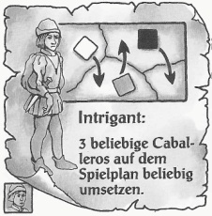
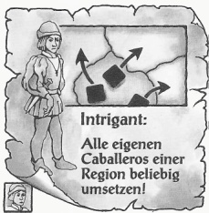
Move all of your own Caballeros in any one region!
Take all of your own Caballeros out of a region and distribute them any to any other regions (except the King’s) and/or into the Castillo. You may return some to their original region.
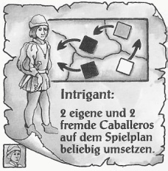
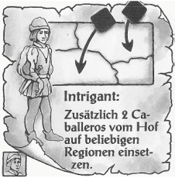
Move 2 more Caballeros from your court to any region.
You are allowed to move 2 Caballeros from your court into any regions (except the King’s) and/or into the Castillo.

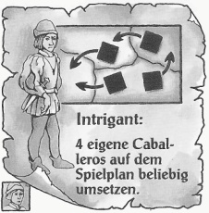
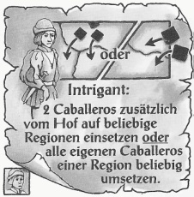
Move 2 Caballeros from your court into any region or move all of your own Caballeros from one region.
You must decide which of the two actions you want to execute. The two choices are identical to the two previously described cards.
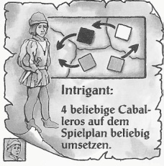
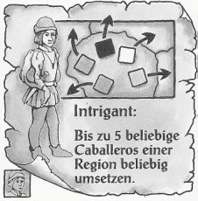
Move up to 5 Caballeros in any one region. (two cards)
You can move up to 5 Caballeros (your own and/or foreign) from one region into any other regions (except the King’s) and/or into the Castillo.
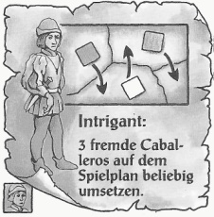
Move any 3 foreign Caballeros on the board.
You can move up to 3 foreign Caballeros from any regions into any other regions (except the King's) and/or into the Castillo.
Move any 3 Caballeros on the board.
You can move any 3 Caballeros (your own and/or foreign) from any regions to any regions (except the King's) and/or into the Castillo.

Move 2 of your own and 2 foreign Caballeros on the board. (two cards)
You can move altogether 2 of your own and 2 foreign Caballeros from any regions into any other regions (except the King's) and/or into the Castillo.
Move any 4 of your own Caballeros on the board.
You can move any 4 of your own Caballeros from any regions into any other regions (except the King's) and/or into the Castillo.
Move any 4 Caballeros on the board.
You can move any 4 Caballeros (your own and/or foreign) from any regions into any other regions (except the King's) and/or into the Castillo.

Action cards in the 2 pile (11 cards)
You may add a maximum of two Caballeros from your court into a region or regions neighboring the King’s region or into the Castillo. Furthermore, you may, if you wish, perform the special action indicated on the card. You may perform the special action either before or after you add your Caballeros.

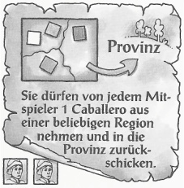
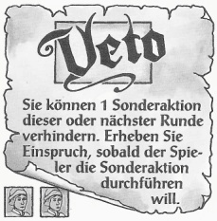
Veto (two cards)
You can prevent one special action during this round or the next round. Announce your objection as soon as the player starts to execute their special action. If you take the veto card then put it before yourself on the table and play it when you want to prevent the execution of a special action. You can prevent only one special action. You cannot prevent adding Caballeros to the board from the court. You may only prevent a special action if you hold the Veto! card and the special action is not yet complete. You may also prevent only part of a special action. For example, assume that a player may move four Caballeros. He has already moved two. You were pleased with these moves. Now he plans to move one more. You don’t like the sound of that, so you play your veto. Your veto prevents the remainder of the special action. After you have played the veto, the card is discarded. If you have not played the veto by the end of the next round, it is discarded.
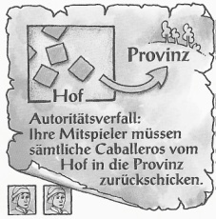
Decay of Authority.
Your fellow players (but not the player who chose this action) must send all of the Caballeros in their courts back to the provinces.
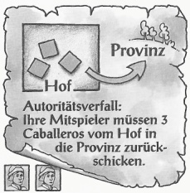
Decay of Authority.
Your fellow players (but not the player who chose this action)must send three Caballeros from their courts back to the provinces.
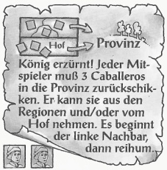
The King returns!
Each fellow player (but not the player who chose this action) must send three Caballeros back to the provinces. He can take them from any regions and/or the court. The player to the left of the player that played the special action begins, then it passes clockwise. Each player must decide which three of their own Caballeros to send back to the provinces.
You send one Caballero from any region from each fellow player back to the provinces.
You decide which Caballeros must return to the provinces.

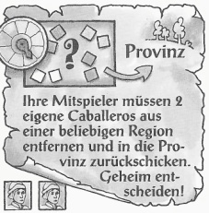
Your fellow players must remove two of their own Caballeros from any region and send them back to the provinces. Decide secretly!
All fellow players (excluding the person who chose the action card)must simultaneously select a region with their secrecy disk. The selected region must contain at least two of their Caballeros. If a player only has at most one Caballero in any region then they must select such a region.
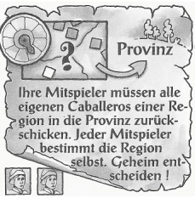
Your fellow players must send all of their own Caballeros from one region back to the provinces. Each player decides which region. Decide secretly!
All fellow players (excluding the person who chose the action card) must select a region in which they have at least one Caballero. The selection is held simultaneously using the secrecy disk.
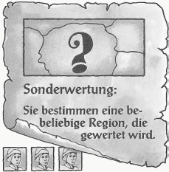
Special Scoring. (three cards)
Pick one region to be scored. You may choose any region, including the King’s region and the Castillo. The scoring follows the standard rules for scoring regions, as described under “Scoring of the Regions.”

Action Cards in the 3 pile (11 cards)
You may add a maximum of three Caballeros from your court into a region or regions neighboring the King’s region or into the Castillo. Furthermore, you may, if you wish, perform the special action indicated on the card. You may perform the special action either before or after you add your Caballeros.

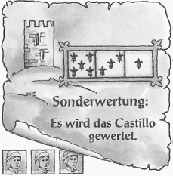
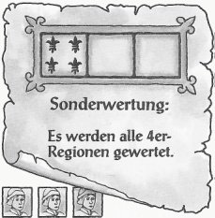
Special Scoring: all ‘4’ regions are scored. (two)
Score all regions with a four lilies in the first space on their scoreboard. The ‘4’ regions are Galicien (4/2/0), Katalonien (4/2/1) and Sevilla (4/3/1). If the scoreboard printed on the game board has been covered by a mobile scoreboard then only consider the values shown on the mobile scoreboard. This is true for all of the other special scorings. The scoring follows the rules given in the section, “Scoring of the Regions.” including the home bonuses and King’s bonus if they apply.
Example 1: A mobile scoreboard showing (8/4/0) lies in Galicien. So Galicien is no longer a ‘4’ region.
Example 2: A mobile scoreboard showing (4/0/0) lies in Granada. So Granada is now a ‘4’ region.
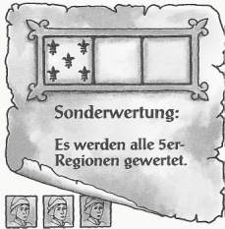
Special Scoring: all ‘5’ regions are scored. (two cards)
This is carried out in the manner described above for the ‘4’ regions. The ‘5’ regions are the Basque country (5/3/1), Aragon (5/4/1) and Valencia (5/3/2). The Castillo is not scored.
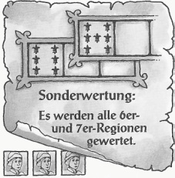
Special Scoring: all ‘6’ and ‘7’ regions are scored.
This is carried out in the manner described above for the ‘4’ regions. The ‘6’ and ‘7’ regions are Altkastilien (6/4/2), Neukastilien (7/4/2) and Granada (6/3/1).
Special Scoring: the Castillo is scored. (two cards)
The Castillo is uncovered. The majority is determined. After the scoring the Castillo is placed over the Caballeros again. The Caballeros remain in the Castillo and are not distributed until the next general scoring.
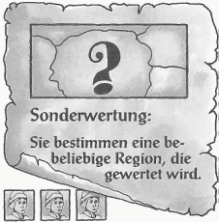
Special Scoring: You may choose any region to score.
You may choose any region including the King’s region or the Castillo, if you wish. The scoring follows the rules described under “Scoring of the Regions.”
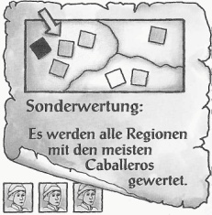
Special Scoring: Score the region(s) with the most Caballeros.
Score the region that contains the highest total of Caballeros from all players combined. Where more than one region has this same highest total then all of them are scored. Ignore the Castillo.
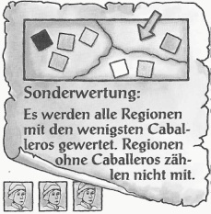
Special Scoring: Score the region(s) with the fewest Caballeros.
Score the region that contains the lowest total of Caballeros from all players combined. Where more than one region has this same lowest total then all of them are scored. Ignore the Castillo, and any regions that contain no Caballeros.
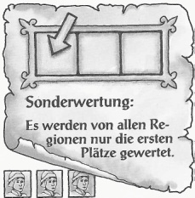
Special Scoring: Score the first place in all regions.
Only the player in first place in each region (not including the Castillo) gets points. If there is a tie nobody gets points.

Action Cards in the 4 pile (11 cards)
You may add a maximum of four Caballeros from your court into a region or regions neighboring the King’s region or into the Castillo. Furthermore, you may, if you wish, perform the special action indicated on the card. You may perform the special action either before or after you add your Caballeros.

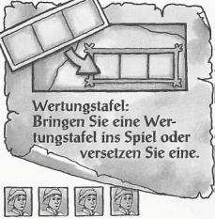
Move a mobile scoreboard. (three cards)
You may move a mobile scoreboard either onto the board for the first time, or into a different region if it is already on the board. A mobile scoreboard may also be placed at the Castillo. The two mobile scoreboards may not be placed in the same region.
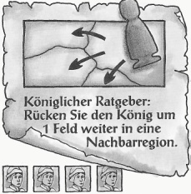
Royal Adviser: Move the King into a neighboring region.
You may move the King no further than one region away from his present position.

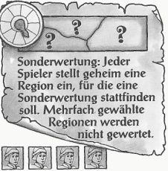
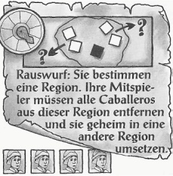
Evict. You choose a region. Your fellow players must move all of their Caballeros out of this region and move them secretly to a different region.
After you have decided the region, all of your fellow players (but not the player who chose this action) that have Caballeros in this region should choose a different region on their secrecy disks. These players then reveal their disks and move their Caballeros to the chosen region. If a player chooses the King's region then their Caballeros return to their court.
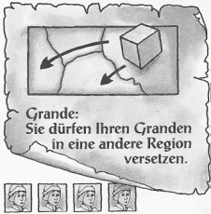
Grande. (two cards)
You may move your Grande into a different region, unless it is in the King’s region, in which case it cannot move. You may choose any region except the Castillo and the King's region. You may choose a region which already contains several Grandes.
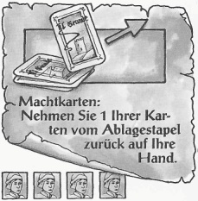
Power Cards. (two cards)
Return a power card that you have played to your hand. You may take back any of the cards you have played, even the one played this round.
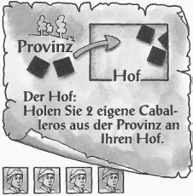
The Court.
Move 2 of your Caballeros from the provinces to your court.

Special Scoring. Each player secretly chooses a region to score. If a region is chosen by more than one player, it is not scored.
All players choose a region on their secrecy disk and reveal them simultaneously. Score all uniquely chosen regions according to the rules under “Scoring the Regions.”

The Action Card in the 5 pile
The 5 pile has only one card, the King’s card. When you choose this card, you may add a maximum of five Caballeros from your court into a region or regions neighboring the King’s region or into the Castillo. Furthermore, you may, if you wish, perform the special action indicated on the card. You may perform the special action either before or after you add your Caballeros.
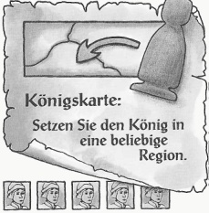
King’s Card.
Move the King into any region. Any region (apart from the Castillo) may be chosen.

Variant Rules
The following variant rules may be used in any combination.

Short Game
For an alternate version of the shorter game play rounds 1–6, skipping rounds 7–9 and the final scoring.

Home Region Advantages
The Grande piece counts as 1 for determining who has the most in a region.
If all of the Caballeros that you add to the board by non-special action go into the Home region then you may add 1 more than the action card allows.

Moving Restrictions
When you are allowed to move Caballeros by special action you may only move the full number allowed on the card if they all move to an adjacent region (or the Castillo). If you want to move one or more any further than this then you only get to move the total it says on the card minus 2.

France
Use the France region from the Expansion as a stand-alone addition to the basic game.
France is like other regions with the following exceptions:
There can only be a maximum of 3 Caballeros in France, and they are placed on the special places shown for them. You may place a Caballero on any vacant space.
Grandes and the King may not be placed in France.
The scores printed on the Caballero spaces (+2 Ambassador, +1 Envoy) are bonuses that are received for having a man there when France is scored.
During scoring, Caballeros may not move from the Castillo to France.

Granada
Granada represents the Muslim controlled areas in the south of Spain.
Grandes and the King may not be placed in Granada.
Caballeros (i.e. Crusaders) may only arrive in Granada from the Castillo, or as a result of moving there through the special action allowed by an action card. They may not arrive there as a result of being added from the court.
Granada is never scored.
If the total number of Caballeros in Granada reaches 12 or more at the end of a player turn, then the region is conquered for Christian Spain. It immediately becomes a totally normal region, and all the above special rules cease to apply. It is also immediately scored double at this point.

The Church
Add to the player’s Caballero’s four black Caballeros to represent Church influence. They will start on the map in two random locations, and count toward the person who currently has Church influence. Church influence may be gained using a new card that is placed into a sixth pile by itself. Church influence is noted using any convenient marker that the players can pass around.
At the start of the game draw two region cards (after you have drawn for home regions and the King’s region). Place two black Caballeros in each of these regions. Place the Church marker to one side— nobody has Church influence at the start of the game.
If the Church marker is at your court you have influence over the Church. You keep it until someone else chooses the Church card in a later round. While you have it you control the four black Caballeros. You may also choose to add one extra Caballero in your turn, either from the provinces into your court or with those you bring from court to the board.
Church Caballeros may be moved by action card just like other Caballeros. They count as foreign to all except the player that currently controls the Church. They may not be moved to the Castillo or to any player’s court or provinces. If playing by the relevant variant rule they may not be moved to France, or to a still-Muslim Granada.
At the start of the game, place the Church card in a sixth pile next to the pile. The Church card is available every round, just as the King’s card is. When you choose the Church card, you may add a maximum of three Caballeros from your court into a region or regions neighboring the King’s region or into the Castillo. Furthermore, you may, if you wish, perform the special action indicated on the card. You may perform the special action either before or after you add your Caballeros.
Church card.
Take the Church marker and place it by your court. You may move 2 of the black Church Caballeros from any regions into any other regions (except the King’s). They may not go into the Castillo.

